[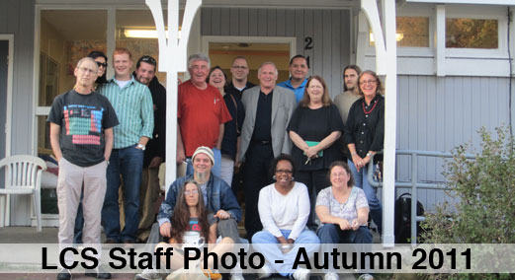](http://www.lawrenceshelter.org/index-1.html)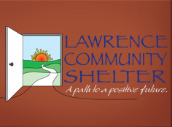



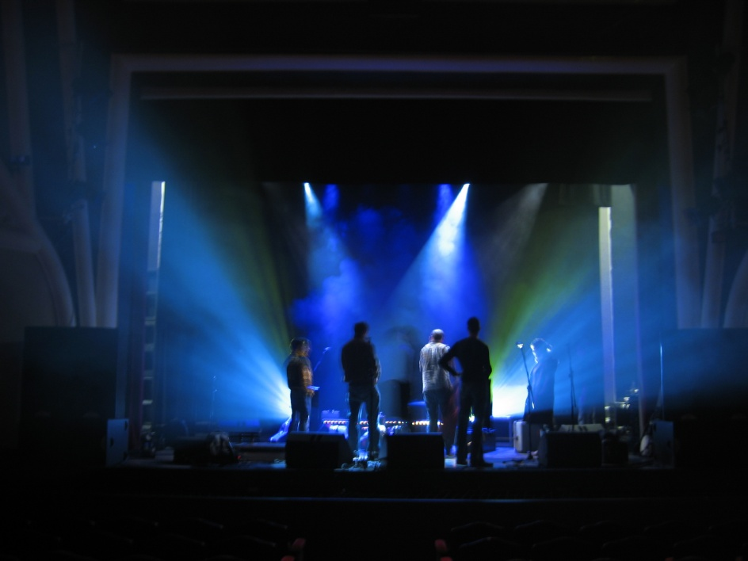

$5 cover and $3 food voucher

All proceeds will go directly to LCS

The BSW Student Group would like to invite you to the annual…

For the Lawrence Community Shelter!

There will be…

A Silent Auction and Raffle

Drink specials including: $2 wells, $4 double wells, and $2 bottles

Live Music including Eric Fitzmorris and the VVA Jazz Band with Harry Miller, Ardys Ramberg ,Paul Matthews & Steve Kapp

Delicious Pizza

AND MUCH MORE!!!

…

Come on Thursday, November 17th from 6-10pm to Abe and Jake’s Landing on 8 E 6th Street Lawrence, KS

Abe and Jakes Benefit